**Login Page**

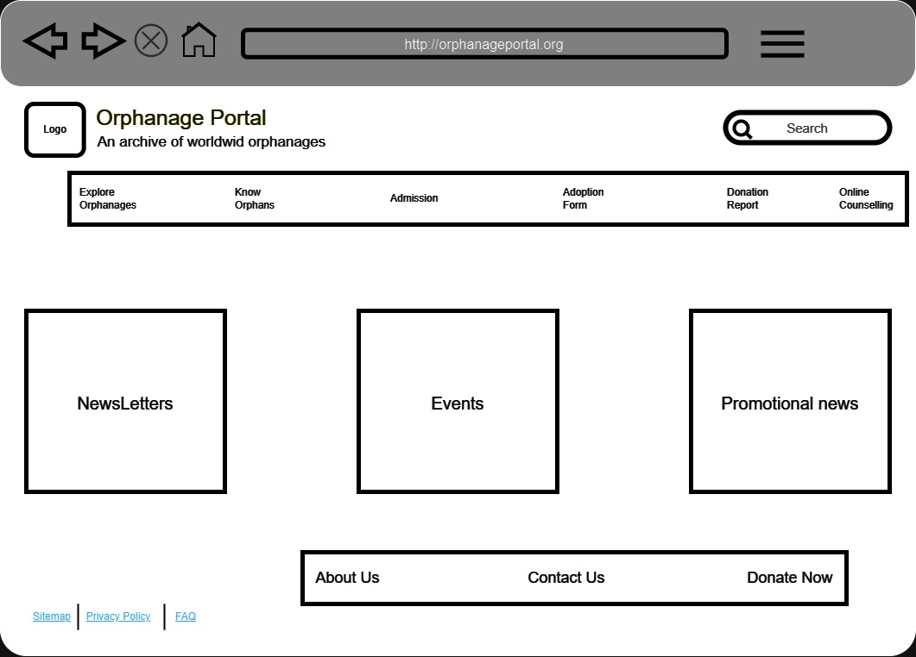.

LANDING PAGE

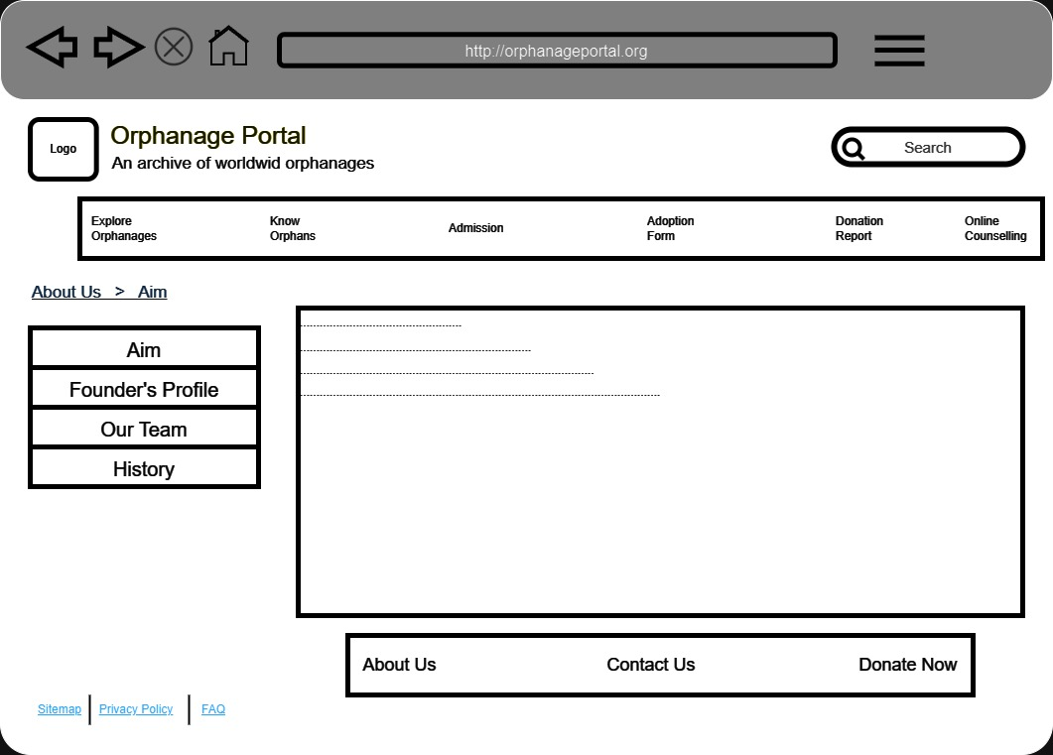.

ABOUT US

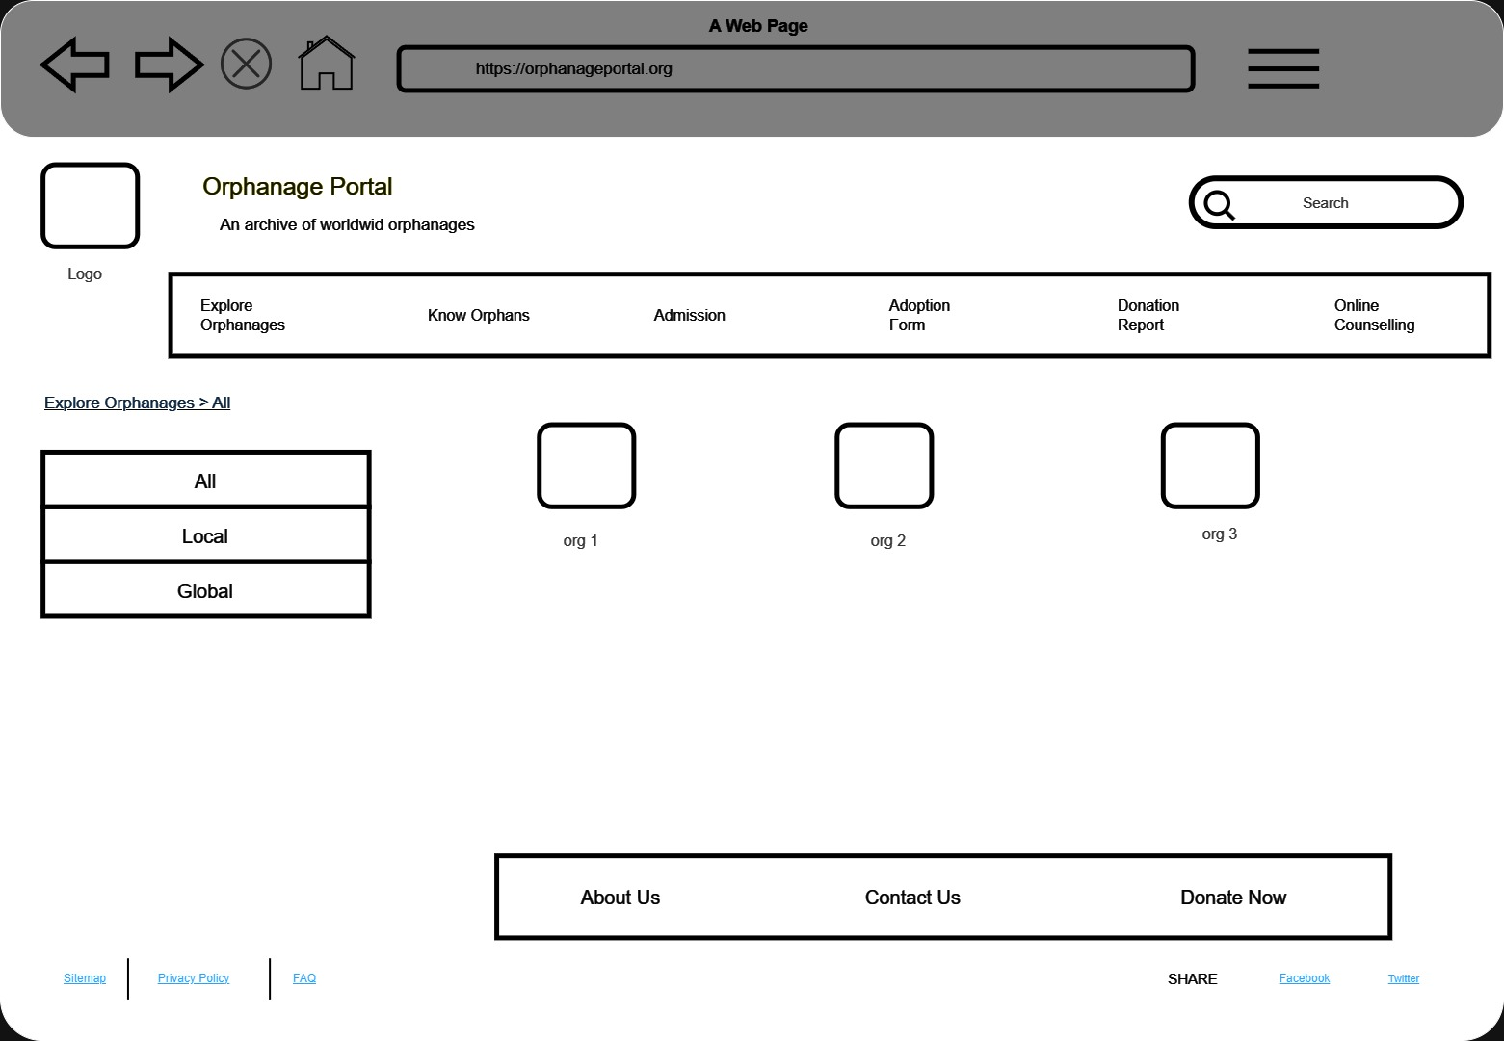.  
EXPLORE ORPAHANAGES

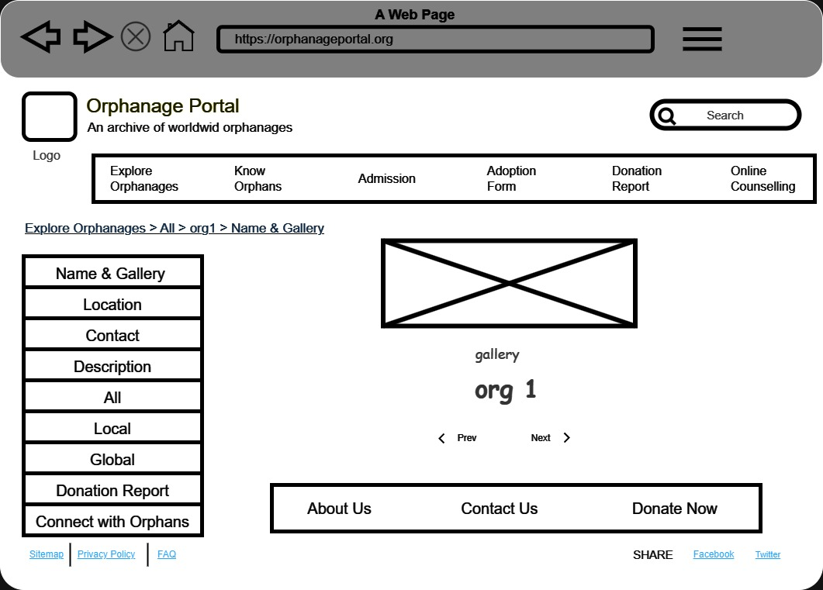.

INFORMATION ABOUT SPECIFIC NGO

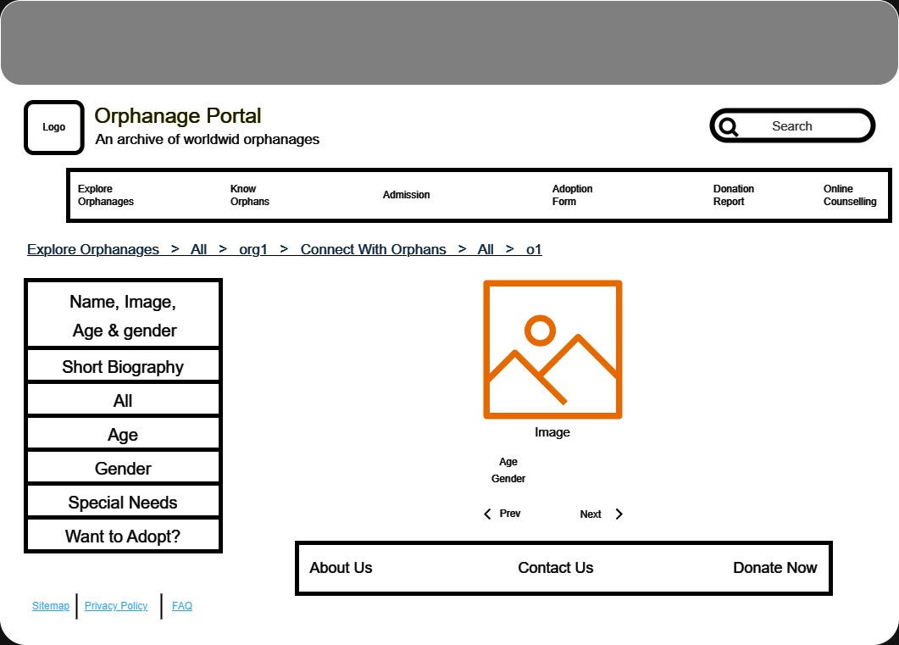.

CONNECT WITH ORPHANS

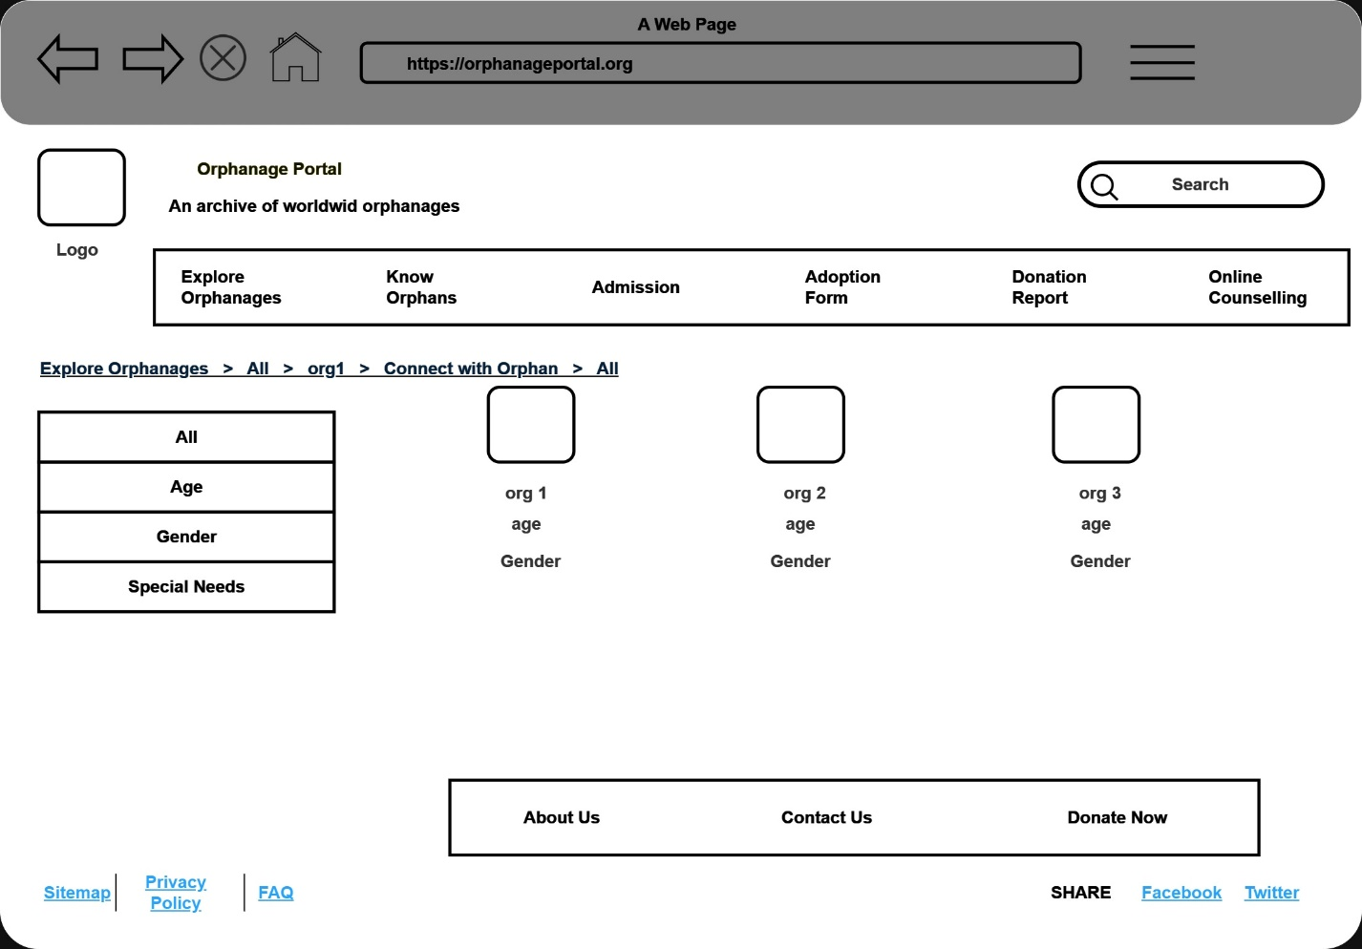.

CONNECT WITH ORPHANS

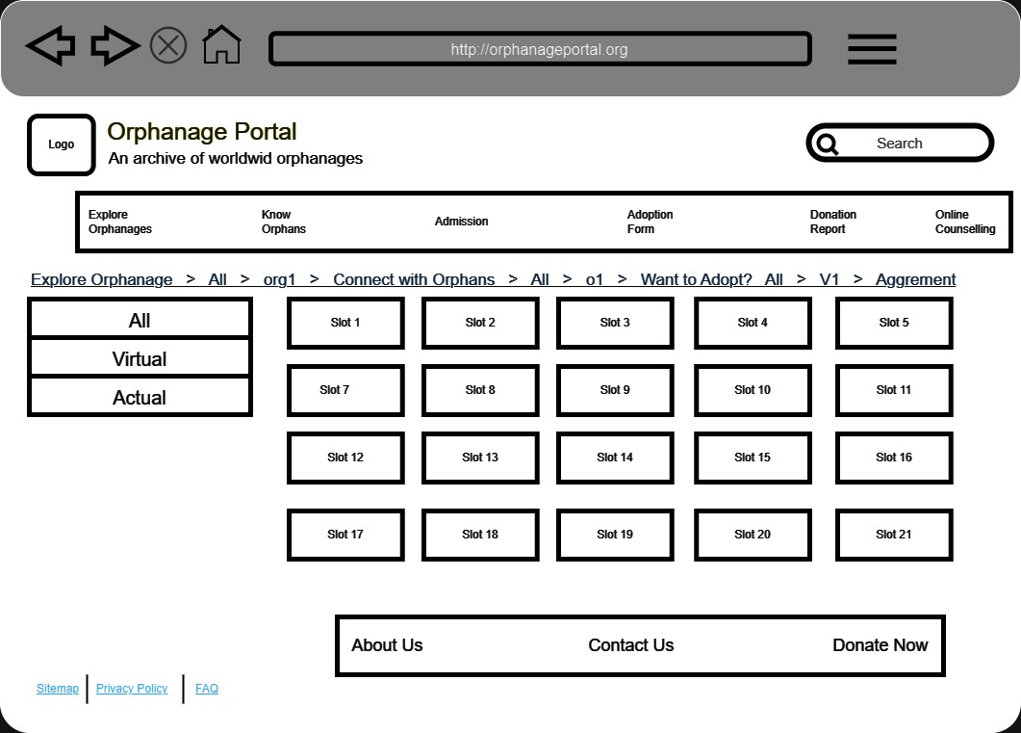.

SLOT BOOKING

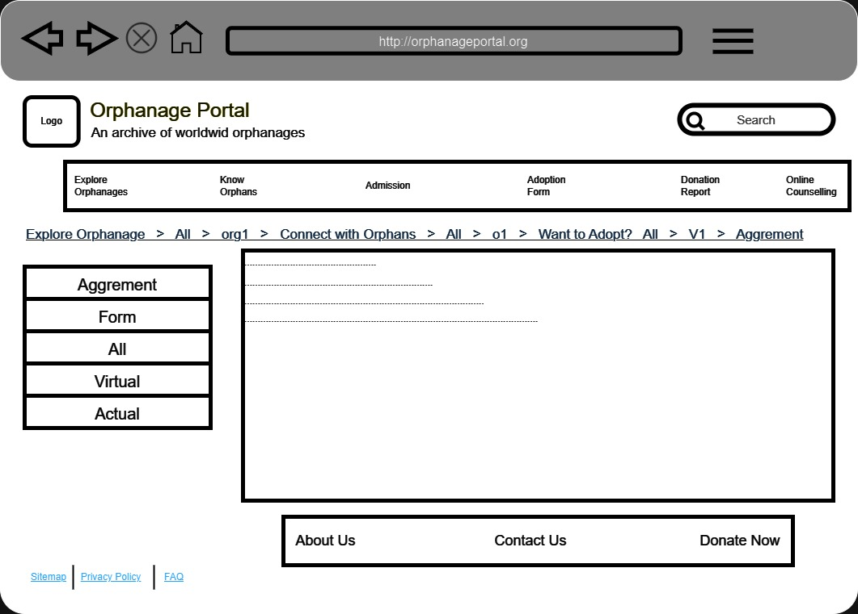.

FINAL AGREEMENT STAGE